Metadata Catalog

🗂️ What Is a Metadata Catalog in a DBMS?
# Source: AI Source: Provided by: [Data Path: Persons Table -> ID Column: 1, Name_En Column: Motasem Essam] -> From: [ChatGPT] on [6/10/2026]
The Metadata Catalog — also called the System Catalog, Data Dictionary, or System Tables — is the "database about the database."
It stores metadata: information about the structure, organization, and rules of the actual data stored in the database.

📋 What Is Metadata?
# Source: AI Source: Provided by: [Data Path: Persons Table -> ID Column: 1, Name_En Column: Motasem Essam] -> From: [ChatGPT] on [6/10/2026]
Metadata means "data about data."
In a database, this includes:
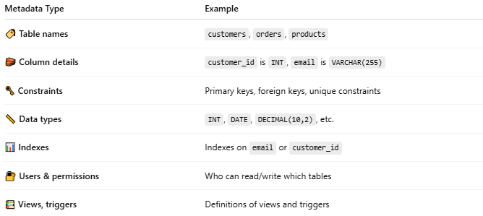
Metadata Type | Example
🏷️ Table names | customers, orders, products
🧱 Column details | customer_id is INT, email is VARCHAR(255)
🗝️ Constraints | Primary keys, foreign keys, unique constraints
📏 Data types | INT, DATE, DECIMAL(10,2), etc.
📊 Indexes | Indexes on email or customer_id
🔐 Users & permissions | Who can read/write which tables
📚 Views, triggers | Definitions of views and triggers

🧩 What Does the Metadata Catalog Do?
# Source: AI Source: Provided by: [Data Path: Persons Table -> ID Column: 1, Name_En Column: Motasem Essam] -> From: [ChatGPT] on [6/10/2026]
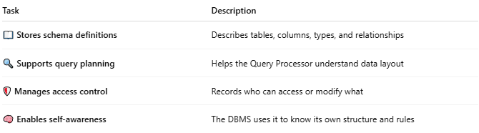
Task | Description
📖 Stores schema definitions | Describes tables, columns, types, and relationships
🔍 Supports query planning | Helps the Query Processor understand data layout
🛡️ Manages access control | Records who can access or modify what
🧠 Enables self-awareness | The DBMS uses it to know its own structure and rules

🛠️ Where Is It Stored?
# Source: AI Source: Provided by: [Data Path: Persons Table -> ID Column: 1, Name_En Column: Motasem Essam] -> From: [ChatGPT] on [6/10/2026]
It’s inside the database itself, often in special system schemas or read-only system tables.

Examples by DBMS:
# Source: AI Source: Provided by: [Data Path: Persons Table -> ID Column: 1, Name_En Column: Motasem Essam] -> From: [ChatGPT] on [6/10/2026]
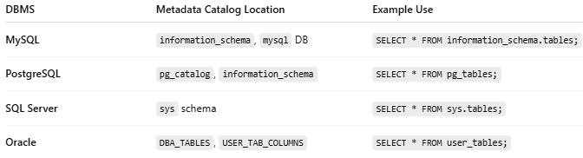
DBMS | Metadata Catalog Location | Example Use
MySQL | information_schema, mysql DB | SELECT * FROM information_schema.tables;
PostgreSQL | pg_catalog, information_schema | SELECT * FROM pg_tables;
SQL Server | sys schema | SELECT * FROM sys.tables;
Oracle | DBA_TABLES, USER_TAB_COLUMNS | SELECT * FROM user_tables;

🔍 Example Query in MySQL
# Source: AI Source: Provided by: [Data Path: Persons Table -> ID Column: 1, Name_En Column: Motasem Essam] -> From: [ChatGPT] on [6/10/2026]
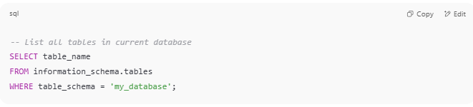
-- List all tables in current database
SELECT table_name
FROM information_schema.tables
WHERE table_schema = 'my_database';

🧠 Why It's Important
# Source: AI Source: Provided by: [Data Path: Persons Table -> ID Column: 1, Name_En Column: Motasem Essam] -> From: [ChatGPT] on [6/10/2026]
- 💡 Developers use it to discover database structure
- ⚙️ DBMS uses it to optimize queries and enforce rules
- 🛠️ Tools like DBeaver or phpMyAdmin rely on it to display your schema

📌 Summary
# Source: AI Source: Provided by: [Data Path: Persons Table -> ID Column: 1, Name_En Column: Motasem Essam] -> From: [ChatGPT] on [6/10/2026]
The Metadata Catalog is the internal registry of your database — it stores all details about tables, columns, users, types, indexes, constraints, and more.
Without it, a DBMS wouldn’t even "know" what’s in your database.

